**AIM** : To write a program to create number guessing game.

**ALGORITHMS** :

STEP1: Start the process by open anaconda command prompt(python).

STEP2: Once open the anaconda command prompt, write the

command in Jupyter notebook.

STEP3: Open the Jupyter notebook page->click new icon->python3, next open the separate jupyter notebook file.

STEP 4: Install Random package.

STEP 5: Install Math Package.

STEP 6: Import Data set.

STEP7: Output will be display for the only save the file name.

STEP8: The program will automatically save.

STEP9: Run the process and Display the Output

**PROGRAM** :

import random

import math

# Taking Inputs

lower = int(input("Enter Lower bound:- "))

# Taking Inputs

upper = int(input("Enter Upper bound:- "))

# generating random number between

# the lower and upper

x = random.randint(lower, upper)

print("\n\tYou've only ",

round(math.log(upper - lower + 1, 2)),

" chances to guess the integer!\n")

# Initializing the number of guesses.

count = 0

# for calculation of minimum number of

# guesses depends upon range

while count < math.log(upper - lower + 1, 2):

count += 1

# taking guessing number as input

guess = int(input("Guess a number:- "))

# Condition testing

if x == guess:

print("Congratulations you did it in ",

count, " try")

# Once guessed, loop will break

break

elif x > guess:

print("You guessed too small!")

elif x < guess:

print("You Guessed too high!")

# If Guessing is more than required guesses,

# shows this output.

if count >= math.log(upper - lower + 1, 2):

print("\nThe number is %d" % x)

print("\tBetter Luck Next time!")

# Better to use This source Code on pycharm!

**OUTPUT :**

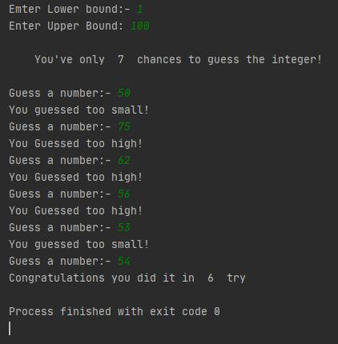

RESULT:

Thus, the above program has been executed successfully.